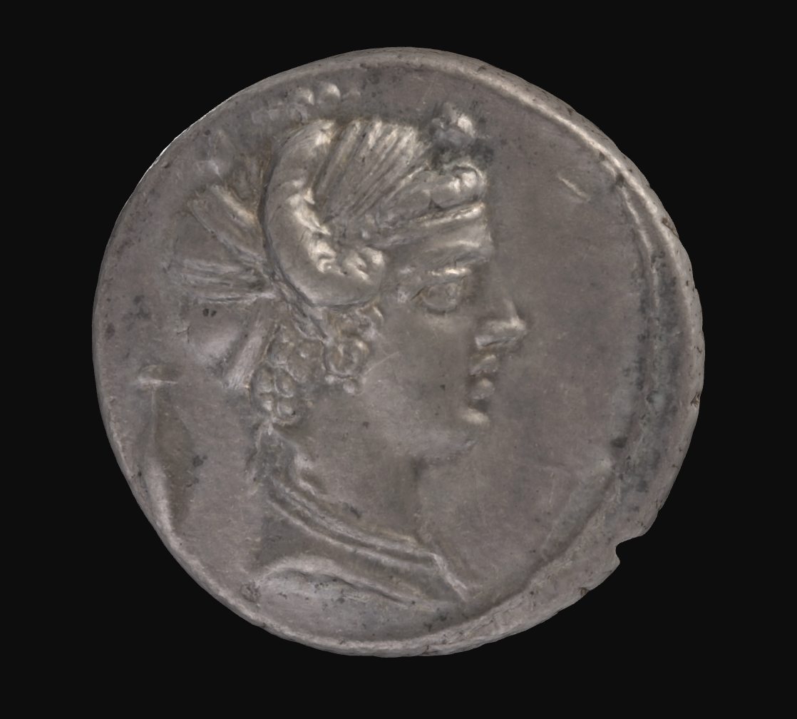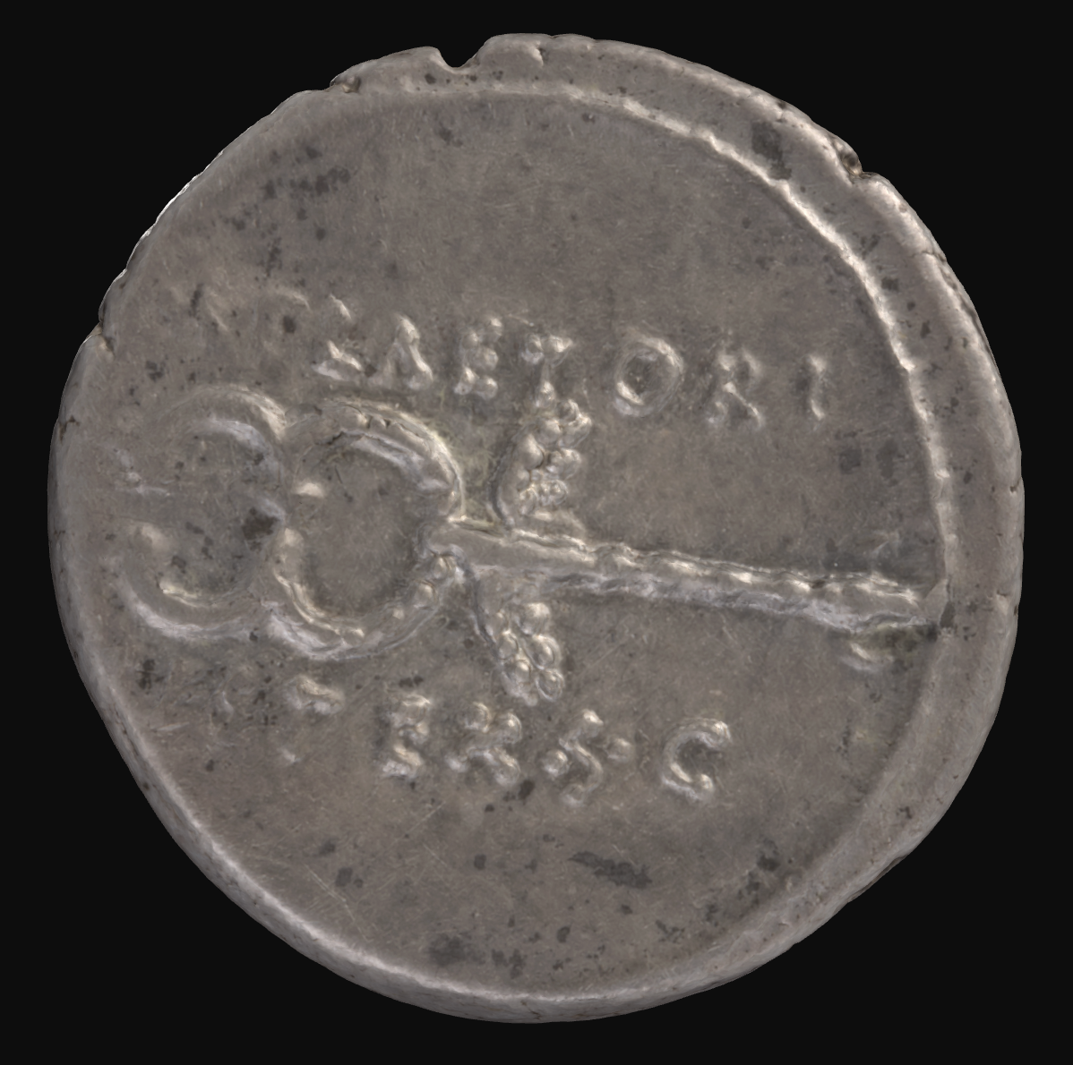

**Fortuna Denarius:**

*This denarius (07GR405/3B), issued by the moneyer Marcus Plaetorius Cestianus, was minted in Rome in 67 BCE, immediately following his curule aedileship. The obverse depicts the bust of Fortuna, with hair draped in the traditional Roman style, decorated with poppy-heads and a cornucopia horn. The reverse depicts the winged caduceus of Mercury, a symbol for wealth, trade, and financial prosperity. Notably, it is Mercury who helps Ceres find Proserpina in the underworld in Roman mythology. His depiction alongside Fortuna emphasises her dominion over prosperity and abundance, as the two deities are often depicted together as a harbinger of successful commerce. The inscription on the reverse names the issuer, Marcus Plaetorius Cestianus, a curule aedile in 67 BCE: ‘M.PLAETORI // CEST EX.S.C.’. This coin was issued during the year of Pompey’s war against the pirates, and thus depicts both a wish for martial luck and the restoration of abundance and safe commerce on the Mediterranean.*

**The Role of the Curule Aedile: Roman Games and Public Spectacle**

The curule aedile had three responsibilities in the Roman Republic: the “care of the city” (cura urbis), the “care of provisions/grain” (cura annonae), and the organisation of ludi, or public games. The aedile oversaw the preservation of public buildings and services, as well as the purchase, importation, and disposal of grain within the city. Politically, their chief responsibility was hosting games and festivals for the Roman people as entertainment. These included chariot races, gladiator battles and theatrical performances. The aedile often used these games to spend lavishly, to win popular favour and patronage for official advancements.

The oldest of the Ludi was the Ludi Romani (Roman Games). This festival was hosted by the curule aedile, and was held annually from September 5th to 19th. It was dedicated to Jupiter, and the celebrations began at his temple on Capitoline Hill. Afterwards, there was a procession into the Circus Maximus, and the games began. The festival’s functions and rituals were led by the cult of Jupiter’s high priest, known as the flamen Dialis. On the September 13, a cow sacrifice was made in the Capitoline Temple, with a feast being held amongst city officials and the Senate. The statues of each member of the Capitoline Triad (Jupiter, Juno, Minerva) were dressed, and taken down to feast with the mortals.

The festival itself included *ludi circenses*, circus games consisting of chariot races and equestrian exhibitions, in which horse riders called *desultores* rode two horses, alternating between each. There were also *ludi scaenici* (Theatrical Performances), with comic plays such as Terence’s *Phormio* being performed. These accompanied the circus games, and were often overshadowed by their spectacle. Also, the employment of gladiator battles was common, and crucial for the aedile, as they provided a lavishly expensive yet powerful opportunity for self-promotion, entertaining potential voters without charging them any money.

**Guiding Questions for Students:**

1. What religious significance did the public games hold for the Romans? Was this foregrounded or rather overshadowed?
2. Why did the curule aedile want the public games to be a spectacle?
3. Why would the curule aedile mint the denarius (07GR405/3B), which depicts the goddess of abundance and fortune alongside a symbol of commerce and trade?

Hint: The curule aedile is concerned with three major aspects of Roman city maintenance!

**Roman Games activity for teachers:**

1. Nominate a student to take on the role of the flamen Dialis, and one to take on the role of the curule aedile.
2. Re-enact some features of the Ludi Romani to familiarise students with the features of Roman Games. This may include:
   1. A banquet of food with the dressed figures of Minerva, Juno, and Jupiter,
   2. Student racing in lieu of chariots,
   3. Creative and theatrical performances
3. Discuss with students the significant role the curule aedile played in the maintenance of the City of Rome, including the production of public spectacle in the Roman Republic.

**Political Patronage of Roman Families: Pompey and the Pirates → Close Passage**

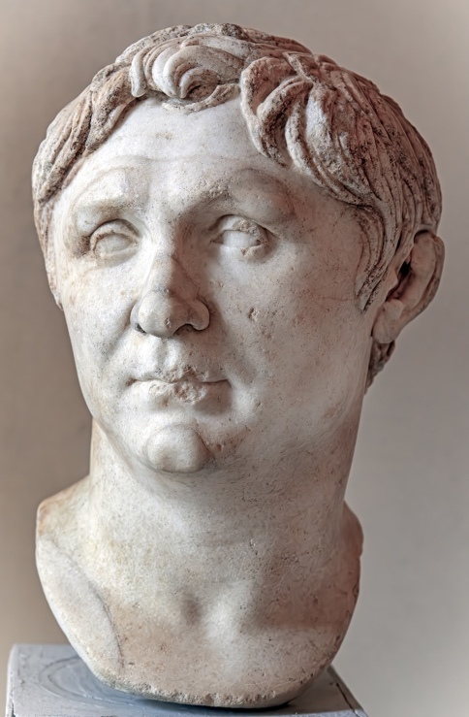

Gnaeus Pompeius Magnus, or Pompey, was one of the great generals and statesmen during the late Roman ______. As a protege of the dictator and general Sulla, and political ally and eventual enemy of ____ Caesar, Pompey was a powerful figure, playing an instrumental role in the growth of Roman territory and control. It is through his close relationship with Sulla that Pompey earned the patronage of the Plaetoria gens, by whom 07GR405/3B was minted. This is because Sulla previously monumentalised the Temple of Fortuna Primigenia at Praeneste, the hometown of the Plaetoria, expressing gratitude to the ______ for his victories in battle.

Following the fall of the Carthaginian Empire, who had been using their powerful ___ to run strict anti-piracy patrols throughout the Mediterranean, a vacuum opened that threatened the security of Rome. As there were no longer measures in place to prevent the sacking of ____ routes along the sea, piracy became far more common, infesting the larger islands and the eastern provinces of the Republic. This heavily impacted the cura annonae (care of provisions) held by the aediles, as the importation of ____ was growing increasingly limited. This made the grain dole, which was at this point an expectation from _____ citizens, difficult to maintain.

Ostia, the port of _____, was raided by _____ in 69 BCE, and this was an emergency that forced the Senate to act. It was proposed that an anti-piracy commander should be implemented, who would have full dominion over the _________ Sea, as well as fifty miles inland, for up to three years. As a military general with two consulships, who was popular with the masses, Pompey was appointed for this role, and was to ______ a fleet to rout the pirates once and for all. However, members of the optimates, who were already deeply distrusting of Pompey’s intentions, were more concerned by this proposal’s dangerous centralisation of ____ than the threat of piracy and _____. Nevertheless, Pompey’s campaign was underway by 67 BCE.

Pompey divided the Mediterranean Sea into fifteen sections, delegating commanders to lead small fleets and _______ piracy in each area. Starting in the west, Pompey cleared the seas around the ______ peninsula, Sicily, and Sardinia, before moving eastwards to the more threatening pirate ___. A major base of piracy was Cilicia, which Pompey defeated in ____ combat. He then held them under ____ until they surrendered to Rome, releasing all their cities and islands. Thus, Pompey’s military campaign was over in just _____ days, with the Mediterranean being rid of piracy and Roman control over the Mediterranean being firmly established.

This conflict was imperative for ______’s growing military career, and his overwhelming ______ led to future appointments. Most notably, his campaigns across the Eastern Mediterranean in 65-62 BCE brought immense wealth to the Republic, using immense military strength to cause the annexation of Syria and the reorganisation of the East.

|  |  |  |  |  |  |  |
| --- | --- | --- | --- | --- | --- | --- |
| **Word Bank** | | | | | | |
| navy | Pompey | Mediterranean | Roman | forty | hubs | trade |
| Julius | power | Rome | naval | success | siege | grain |
| eliminate | Republic | Italian | command | famine | goddess | pirates |